 | 13.3.1 Editors - Shader Editor - Sidebar - Node Tab
Table of content
Node Tab - Node Panel 2
Name 2
Label 2
Color sub menu 2
Color checkbox 2
Presets 2
Color 2
Node color specials 3
Copy Color 3
Node Tab - Properties Panel 3
Node Tab - Properties Panel with Image node 3
Image Property 4
Image Browser 4
New / Open 4
Image Edit Box 4
Fake User 4
Open Image 4
Remove 4
Source 4
Source Type Single Image 4
Path edit box 5
Pack 5
Path edit box 5
Open 5
Refresh 5
Color Space 5
Alpha 5
Half Float Precision 5
View as Render 5
Seam Margin 5
Source Type Movie + Image Sequence 6
Path edit box 6
Pack 6
Path edit box 6
Open 6
Refresh 6
Info string 6
Frames 6
Match Movie Length 6
Start 6
Offset 6
Cyclic 6
Auto Refresh 7
Deinterlace 7
Color Space 7
Alpha 7
Half Float Precision 7
View as Render 7
Seam Margin 7
Source Type Generated 7
X / Y 7
Float Buffer 7
Generated Type Blank 8
Color 8
Generated Type UV Grid 8
Generated Type Color Grid 8
Color Space 8
Half Float Precision 8
View as Render 8
Seam Margin 8
Source Type Udim 8
Info string 9
Color Space 9
Alpha 9
Half Float Precision 9
View as Render 9
Seam Margin 9

Node Tab - Node Panel

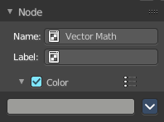
In this panel you can give nodes and node groups a name and a label, and change its color.

Name
The type of the node.

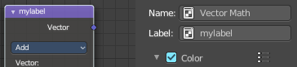
Label
The label name of the node.

Color sub menu

Color checkbox
The Color checkbox turns custom color on or off.

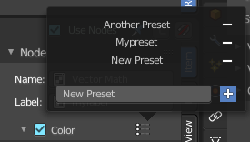
Presets
Store some color presets and reuse them. They are stored globally, and transfers to other blend files.

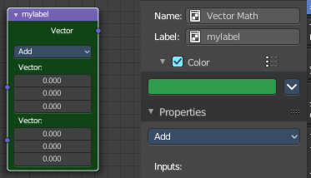
Color
Choose a custom color. A click at the color field will open a color picker.

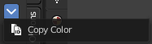
Node color specials

Copy Color
Allows you to copy the color.

Node Tab - Properties Panel
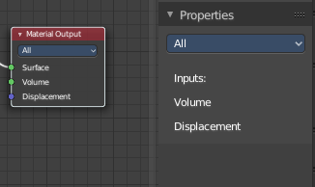
This panel shows usually the same properties than the properties at the node. These properties are already explained in the Add menu chapters. So we won't repeat them here.

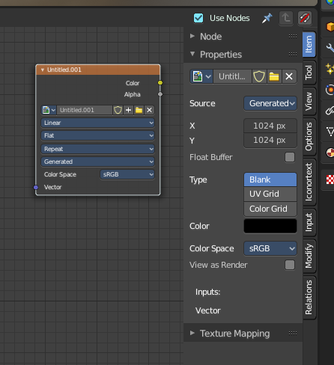
But there are exceptions like the Image node. Here the Properties panel shows much more options than at the node. It shows all the possible image settings. We will explain the extra options here.

Node Tab - Properties Panel with Image node
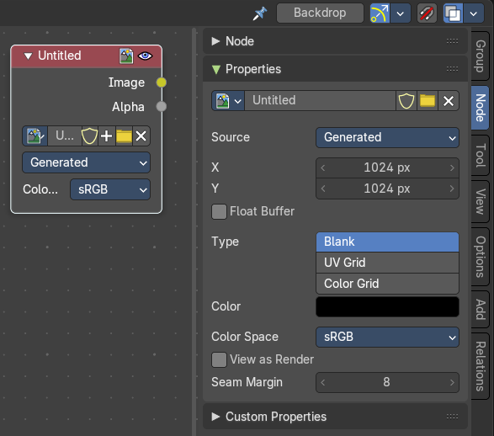
Contains image related settings. Size, type, and so on.

Image Property
Load an image and / or switch to other images.
From left to right ...

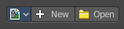
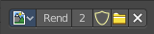

Image Browser
This is a list of the images in the scene. Allows you to switch to other images.

New / Open
When nothing is loaded then you will see the New / Open buttons to load a new image, or to create a new one.

Image Edit Box
The name of the currently selected image. And you can rename the image here too.

Fake User
Wit this button you assign a fake user to this selected image.
Data, like images, that is not longer linked to anything else gets removed when you save and reload a scene. Bforartists has the concept of fake users to go around this behavior. An image with a fake user is in fact linked to something. And so it is not lost when you save and reload the scene.

Open Image
Load an image

Remove
Delete the image.

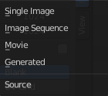
Source
Choose the image type. This type gets usually automatically set. When you create a new image, then this image is generated. When you load an image then the Source switches to Single Image.
Generated images does not have a path.

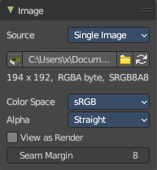
Source Type Single Image

#

Path edit box

Pack
With this button you can pack the movie or the image sequence into the blend file. It gets packed when you save the blend file the next time.

Path edit box
See and edit the path to your movie or image sequence files.

Open
Open a new movie or image sequence files. A file dialog will appear.

Refresh
Reread the movie or image sequence files.

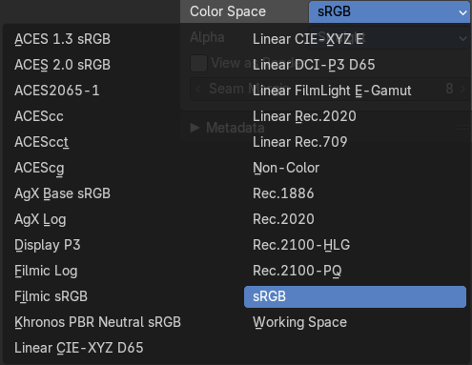
Color Space
The color space for the image.

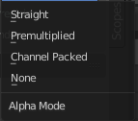
Alpha
How to calculate the alpha channel.

Half Float Precision
Just with image material that uses 32 bit float. Use just 16 Bit per channel instead of the full 32 bit. This lowers the memory usage while rendering.

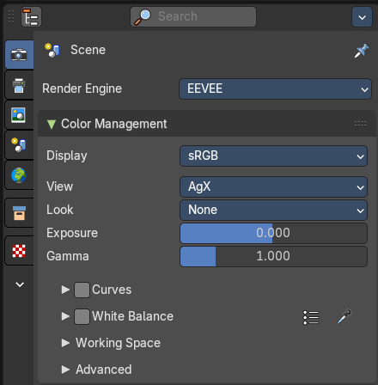
View as Render
Display the image with using the color management settings. The color management can be adjusted in the properties editor in the Render tab.

Seam Margin
This option belongs to the UV Editor, and has no effect in the Image editor. Take a margin into account when fixing UV seams during painting.

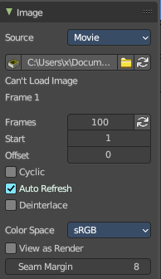
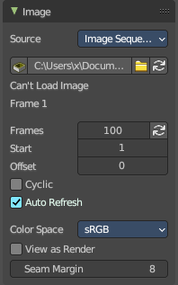
Source Type Movie + Image Sequence


Path edit box

Pack
With this button you can pack the movie or the image sequence into the blend file. It gets packed when you save the blend file the next time.

Path edit box
See and edit the path to your movie or image sequence files.

Open
Open a new movie or image sequence files. A file dialog will appear.

Refresh
Reread the movie or image sequence files.

Info string
Some information about the currently loaded movie. Frames, resolution and color space.

Frames
The number of frames of the movie or image sequence.

Match Movie Length
Set Users Image Length to the one of this video.

Start
The start frame of the movie or image sequence

Offset
Offset the number of the frame to use in the animation. -1 means off.

Cyclic
Cycle the images in the movie.

Auto Refresh
Always refresh image on frame changes.

Deinterlace
Deinterlace the movie file on load.


Color Space
Choose the color space type for the movie or image sequence files.

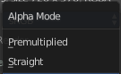
Alpha
Choose the alpha channel mode. Straight or Premultiplied.

Half Float Precision
Just with image material that uses 32 bit float. Use just 16 Bit per channel instead of the full 32 bit. This lowers the memory usage while rendering.

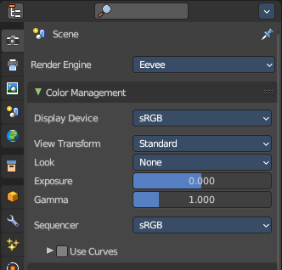
View as Render
Display the image with using the color management settings. The color management can be adjusted in the properties editor in the Render tab.

Seam Margin
This option belongs to the UV Editor, and has no effect in the Image editor. Take a margin into account when fixing UV seams during painting.

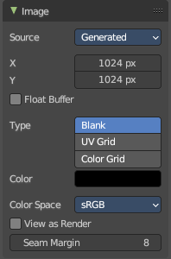
Source Type Generated

X / Y
The image width and height.

Float Buffer
Use a floating point buffer. 8 Bit images uses integers. 32 Bit works with floats.


Generated Type Blank
This type displays an image with one blank color

Color
The color of the blank image.


Generated Type UV Grid
This type displays a with a black and white checker texture but colored dots.


Generated Type Color Grid
This type displays a with a colored checker texture with numbers.


Color Space
Choose the color space type for the image.

Half Float Precision
Just with image material that uses 32 bit float. Use just 16 Bit per channel instead of the full 32 bit. This lowers the memory usage while rendering.

View as Render
Display the image with using the color management settings. The color management can be adjusted in the properties editor in the Render tab.

Seam Margin
This option belongs to the UV Editor, and has no effect in the Image editor. Take a margin into account when fixing UV seams during painting.

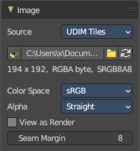
Source Type Udim
UDIM is an enhancement to the UV mapping and texturing workflow. And does not belong here. But in the UV Editor. It is just in the list because it shares the same menus with the UV Editor.

Info string
Some information about the currently loaded image. Resolution and color space.


Color Space
Choose the color space type for the movie or image sequence files.

Alpha
Choose the alpha channel mode. Straight or Premultiplied.

Half Float Precision
Just with color space sRGB. Use just 16 Bit per channel instead of the full 32 bit. This lowers the memory usage while rendering.

View as Render
Display the image with using the color management settings. The color management can be adjusted in the properties editor in the Render tab.

Seam Margin
This option belongs to the UV Editor, and has no effect in the Image editor. Take a margin into account when fixing UV seams during painting.

